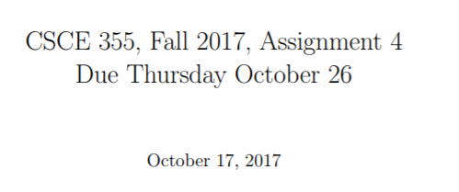



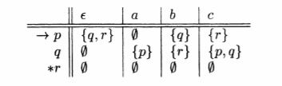

<insert answer here>



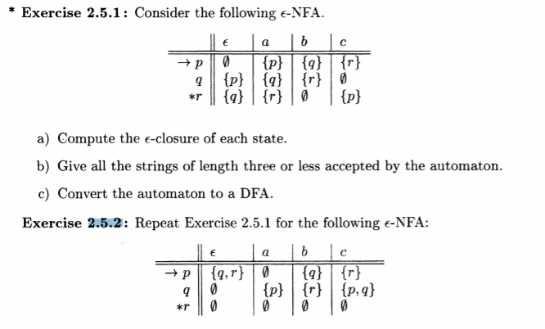

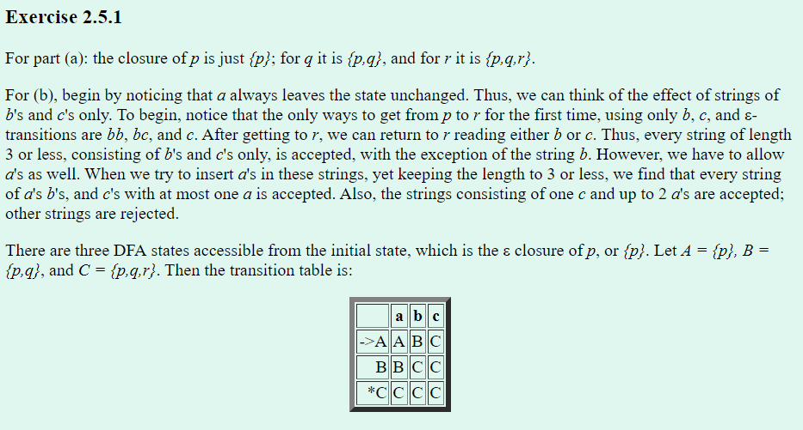

<insert answer here>



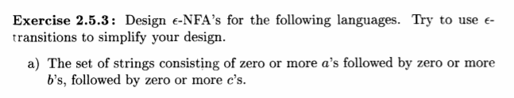v

<insert answer here>

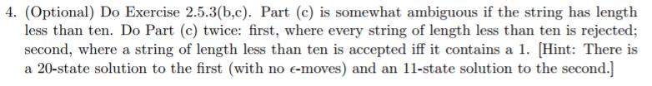

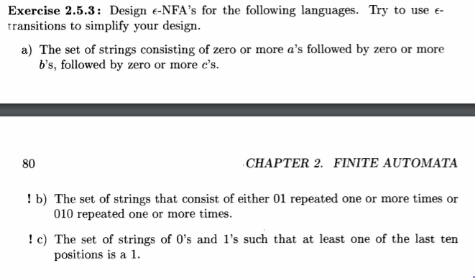

<insert answer here>



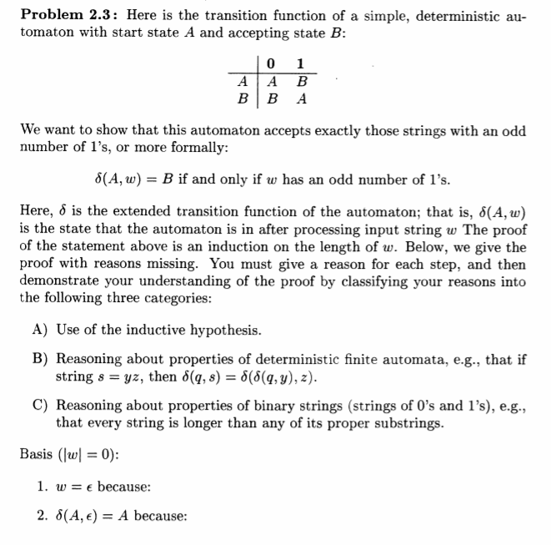

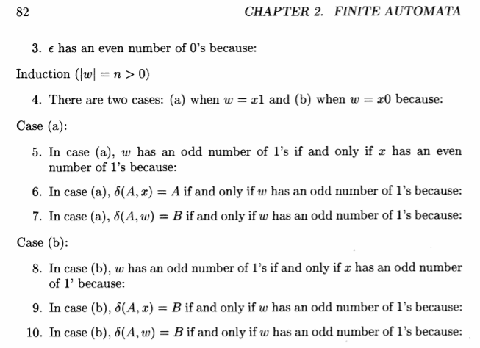

<insert answer here>

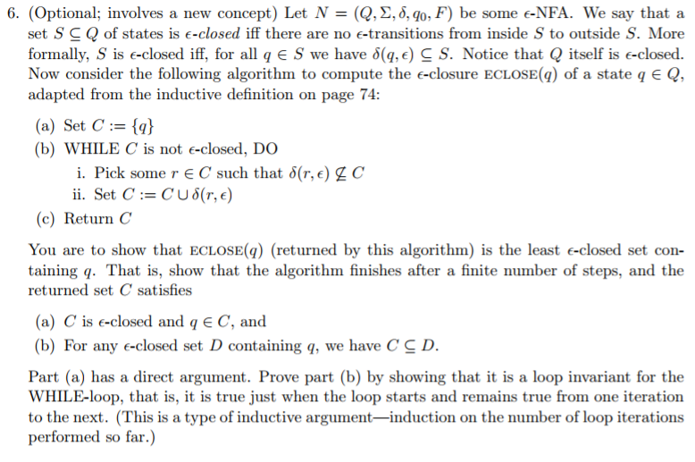

<insert answer here>

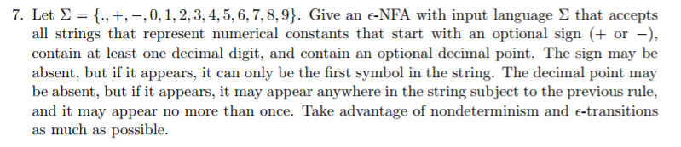

<insert answer here>



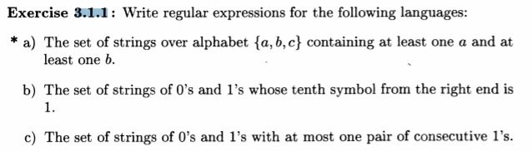

<insert answer here>



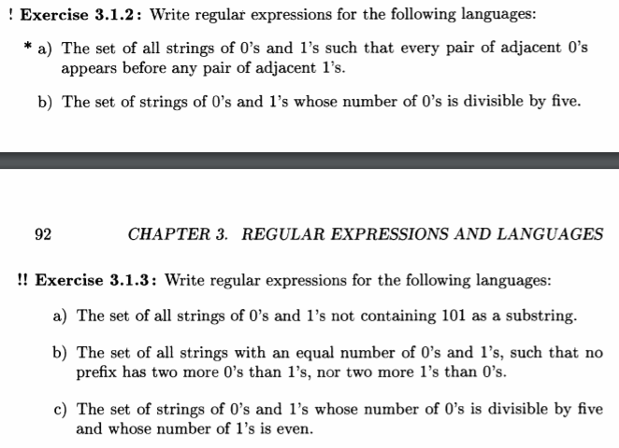

<insert answer here>



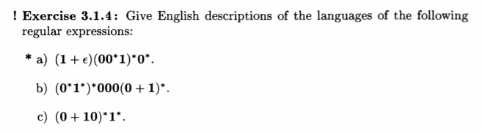

<insert answer here>



<insert answer here>



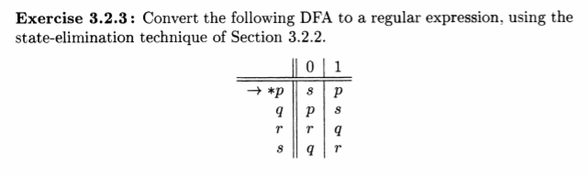

<insert answer here>



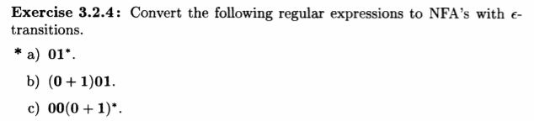

<insert answer here>

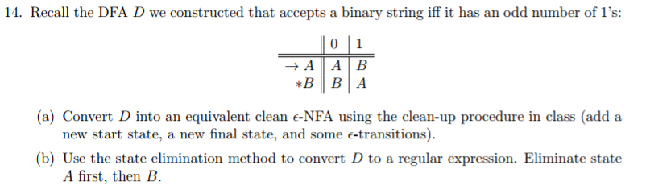

<insert answer here>



<insert answer here>

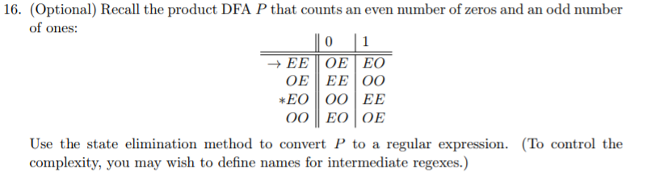

<insert answer here>